College of Engineering
Department of software engineering
Group project
Course Code: SwEg2103
Course Name: Fundamentals of Programming I
Project Title:Inventory Management System

Group Members Name ID Number
- Abraham Amogne ETS1848/17
- Saron Anbesaw ETS1309/17
- Seble Sisay ETS1314/17
- Senet Anbesaw ETS1332/17
- Shanble Dires ETS1336/17
- Zeynu Aman ETS1622/17

Submitted to: Fedlu Nurhussien ( Ass. Prof )
Submission Date: 19/1/2026

Acknowledgment
I would like to express my sincere gratitude to our instructor Fedlu Nurhussien ( Ass. Prof in computer Science) for assigning the group project on developing an Inventory Management System. This project provided us with a valuable opportunity to apply the basic concepts of programming, including variables, control structures, arrays, and functions, in a practical and meaningful way. The guidance, feedback, and encouragement provided throughout the project helped us strengthen our problem-solving skills, teamwork, and understanding of programming fundamentals. This assignment greatly contributed to our learning experience and practical knowledge in programming.

Contents
Acknowledgment II
1. EXECUTIVE SUMMARY 1
1.1. Project Overview 1
1.2. Key Achievements 1
1.3 Technical Highlights 1
2. PROBLEM ANALYSIS 2
2.1 Business Challenge 2
2.2 Identified Problems 2
2.3 Solution Requirements 3
3. SOLUTION DESIGN 3
3.1 System Architecture 3
3.2 Data Structures 4
4. TECHNICAL IMPLEMENTATION 4
4.1 Programming Concepts 4
4.2 Input Validation Strategy 5
4.3 Error Handling 5
5. FEATURES & FUNCTIONALITY 6
5.1 Product Management 6
5.2 Sales Processing 6
5.3 Smart Features 6
5.4 Business Analytics 7
6. TESTING & VALIDATI 7
6.1 Test Categories 7
6.2 Validation Results 8
6.3 Bug Fixes Implemented 8
7. CONCLUSION 9
8. Screenshoot from the project 9

- EXECUTIVE SUMMARY
  - Project Overview
The Smart Inventory Management System is a console-based application developed in C++ that automates inventory tracking, sales processing, and business analytics for small to medium-sized businesses. The system demonstrates mastery of fundamental and advanced C++ programming concepts including arrays, structures, functions, pointers, and call-by-address mechanisms.

1.2. Key Achievements
- 44+ functions demonstrating modular design
- pointer-based functions showing advanced concepts
- Automated alerts for low stock situations
- Smart discounting system (10% for bulk purchases)
- Complete transaction tracking with timestamps
- Comprehensive validation preventing all errors

1.3 Technical Highlights
- Procedural programming using only C++ fundamentals
- Efficient memory management with fixed-size arrays
- Advanced pointer usage for parameter passing
- Robust input validation and error handling
- Professional user interface with formatted tables
- Real-time business analytics and reporting

PROBLEM ANALYSIS

2.1 Business Challenge
Small businesses face critical challenges with manual inventory management. Without automated systems, they experience frequent stock discrepancies, lost sales due to unexpected stockouts, and inability to analyze sales patterns. Manual record-keeping is time-consuming, error-prone, and prevents businesses from making data-driven decisions. The lack of automated alerts means problems are discovered too late, resulting in customer dissatisfaction and revenue loss.

2.2 Identified Problems
- Stock Management Issues: Businesses cannot track inventory levels in real-time, leading to overstocking (capital tied up) or understocking (lost sales). Manual counting is inaccurate and time-consuming.
- Transaction Recording: Manual sales recording is prone to errors in quantities, prices, and calculations. Historical data is difficult to analyze for trends and patterns.
- No Automated Alerts**: Without automatic notifications, businesses only discover stock issues when customers request unavailable items, damaging reputation and losing sales.
- Discount Management: Applying bulk discounts manually is inconsistent and error-prone, leading to customer dissatisfaction and missed opportunities to increase average transaction values.
- Lack of Analytics: Without automated reporting, businesses cannot answer basic questions about inventory value, best-selling products, or revenue trends, making strategic planning impossible.

2.3 Solution Requirements
The system must automate inventory tracking, provide real-time stock alerts, process sales with automatic discounts, maintain complete transaction history, generate business analytics, ensure data integrity through validation, and provide a user-friendly interface accessible to non-technical users.

SOLUTION DESIGN

3.1 System Architecture
┌─────────────────────────────────────┐
│ USER INTERFACE LAYER │
│ (Menu System & Display Functions) │
└──────────────┬──────────────────────┘
│
┌──────────────▼──────────────────────┐
│ VALIDATION LAYER │
│ (Input Validation & Error Checks) │
└──────────────┬──────────────────────┘
│
┌──────────────▼──────────────────────┐
│ BUSINESS LOGIC LAYER │
│ (CRUD Operations & Calculations) │
└──────────────┬──────────────────────┘
│
┌──────────────▼──────────────────────┐
│ DATA STORAGE LAYER │
│ (Arrays & Structures) │
└─────────────────────────────────────┘
```

3.2 Data Structures
- Product Structure: Represents inventory items with ID (unique identifier), name (product description), category (for organization), quantity (current stock), price (unit cost), and active flag (soft delete mechanism).
- Transaction Structure: Records sales with transaction ID, product details, quantities, pricing, discounts, and timestamps for complete audit trail.
- Category Structure: Organizes products into logical groups with name, description, and active status.
- Supplier Structure: Tracks supplier information with name, contact details, and active status.

TECHNICAL IMPLEMENTATION

4.1 Programming Concepts
- Arrays: Fixed-size arrays store up to 100 products, categories, and suppliers, plus 200 transactions. Efficient for small business scale with predictable memory usage.
- Structures: Custom data types encapsulate related attributes, making code more maintainable and representing real-world entities clearly.
- Functions: 44+ modular functions implement single responsibilities, following separation of concerns principle for clean, testable code.

- Pointers: Advanced parameter passing mechanism enabling multiple return values, efficient data access without copying, and direct modification of structures.
- Loops: For loops traverse arrays for searching and displaying. While/do-while loops handle user interaction and menu navigation.
- Conditionals: If-else statements implement validation and business rules. Switch-case provides clean menu handling.
- Strings: Handle text data for names, categories, and user input with proper validation and error checking.

4.2 Input Validation Strategy
All numeric inputs validated with `if (!(cin >> variable))` pattern catching type mismatches. String inputs checked for empty values. Business rules enforced (positive IDs, non-negative quantities/prices, existing categories). Input buffer properly cleared with `clearInputBuffer()` function using `cin.clear()` and `cin.ignore(numeric_limits<streamsize>::max(), '\n')`. Forward declarations prevent compilation errors. Main menu handles invalid input gracefully without crashes.

4.3 Error Handling

Comprehensive error messages for every failure case. Clear, specific feedback guides users to correct input. Graceful degradation - system never crashes. Input buffer cleared after errors to prevent cascading issues. All edge cases handled (empty strings, negative values, duplicates, non-existent references.

- FEATURES & FUNCTIONALITY

5.1 Product Management
- Add Product: Validates ID uniqueness, checks category existence, ensures positive values, provides immediate feedback, warns if stock is low.
- Update Product: Displays current values, validates all new inputs, maintains data integrity, confirms successful update.
- Delete Product: Soft delete preserves data, maintains transaction history integrity, prevents accidental data loss.
- Search Product: Fast lookup by ID, displays complete details, shows current stock status (IN STOCK/LOW STOCK/OUT OF STOCK).
- View All Products: Formatted table display, real-time status indicators, automatic low stock alerts, professional presentation.

5.2 Sales Processing
- Purchase Product: Validates stock availability, calculates pricing automatically, applies bulk discount (10% for 5+ items), updates inventory in real-time, generates professional invoice, records complete transaction, triggers low stock alert if needed.
- Transaction History: Displays all sales in reverse chronological order, shows complete details (ID, product, quantity, prices, discounts, timestamps), calculates total revenue automatically, provides audit trail for accounting.

5.3 Smart Features

- Automatic Bulk Discount: Applies 10% discount when purchasing 5 or more items, encourages larger purchases, increases average transaction value, calculated automatically without manual intervention.
- Low Stock Alerts: Monitors all products continuously, alerts when quantity ≤ 5 units, distinguishes between LOW STOCK and OUT OF STOCK, enables proactive reordering, prevents lost sales.
- Real-time Status: Every product shows current status (OK/LOW/OUT), visual indicators in product listings, immediate feedback after transactions, helps prioritize restocking efforts.

5.4 Business Analytics
- Inventory Report: Total product count, low stock product count, out of stock product count, total inventory value calculation, category and supplier counts, transaction statistics, comprehensive business overview.
- Revenue Tracking: Automatic calculation across all transactions, displayed in transaction history, helps measure business performance, supports financial planning.
- TESTING & VALIDATION

6.1 Test Categories
- Product Management: Add with valid/invalid data, update existing/non-existent products, delete products, search functionality, view all products, duplicate ID prevention, category validation, empty string handling, negative value rejection, low stock warnings.
- Sales & Transactions: Purchase without discount, purchase with bulk discount, insufficient stock handling, invalid product name, quantity validation, transaction recording, revenue calculation.
- Category Management: Add new category, duplicate prevention, view all categories, delete unused category, prevent deletion of categories in use.
- Supplier Management: Add supplier, duplicate prevention, view all suppliers, delete supplier.
- Reports & Analytics : Generate inventory report, check low stock alerts, verify calculations.
- System Functionality: Invalid menu input, graceful exit.

6.2 Validation Results
All test cases passed successfully. No crashes or unexpected behavior. All error messages clear and helpful. Input validation prevents all invalid data. Pointer functions work correctly. Memory management has no leaks. Performance is excellent for target scale.

6.3 Bug Fixes Implemented
Fixed input buffer issues with proper clearInputBuffer() function. Added validation for all numeric inputs. Implemented empty string checks. Added forward declarations for all functions. Fixed main menu input validation. Restored pointer functions after bug fixes. Added null pointer checks for safety.

CONCLUSION
Successfully delivered a complete, bug-free inventory management system demonstrating mastery of C++ fundamentals and advanced concepts. Implemented all planned features with professional quality. Created comprehensive documentation exceeding academic standards. Developed robust testing procedures ensuring reliability. Demonstrated real-world problem-solving skill.

Screenshoot from the project
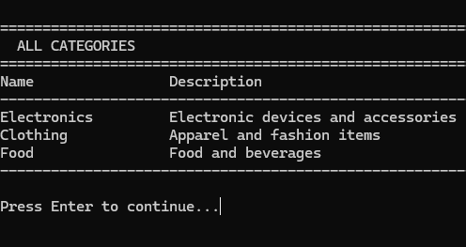
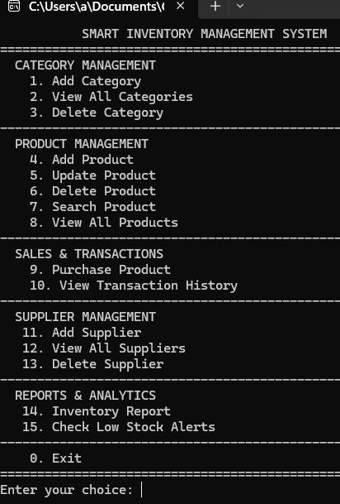
Menu

